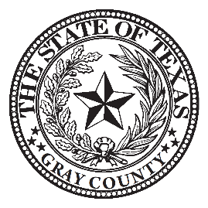

2022 HOLIDAY SCHEDULE

NOTICE TO ALL OFFICE HOLDERS AND COUNTY EMPLOYEES:

County offices, except for the Sheriff’s Office, will be closed for the following Holidays:

New Year's Day
President's Day
Good Friday
Memorial Day
Independence Day
Labor Day
Veterans' Day
Thanksgiving

Christmas Eve (Observed)
Christmas Day (Observed)
Monday
Monday
Friday
Monday
Monday
Monday
Friday
Wednesday (Noon)
Thursday
Friday
Friday
Monday
January 3, 2022
February 21, 2022
April 15, 2022
May 30, 2022
July 4, 2022
September 5, 2022
November 11, 2022
November 23, 2022
November 24, 2022
November 25, 2022
December 23, 2022
December 26, 2022

Please make arrangements for standby services as may be necessary.

Chris Porter
Gray County Judge

